Name: Anshi Mathur

Batch Code: LISUM11: 30

Submission Date: 28 July 2022

Submitted To: Github

Final Output :

https://github.com/anshimathur0325/Diabetes-ML-Flask-App

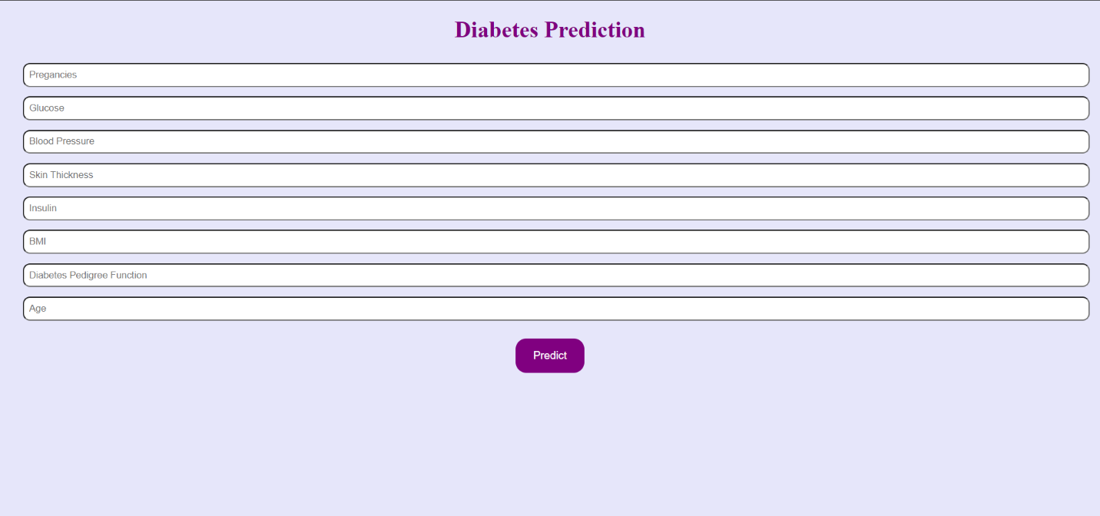

Step 1: I created a model using python to train the computer with a logistic regression classifier. This is one of the most accurate classifiers for this data set.

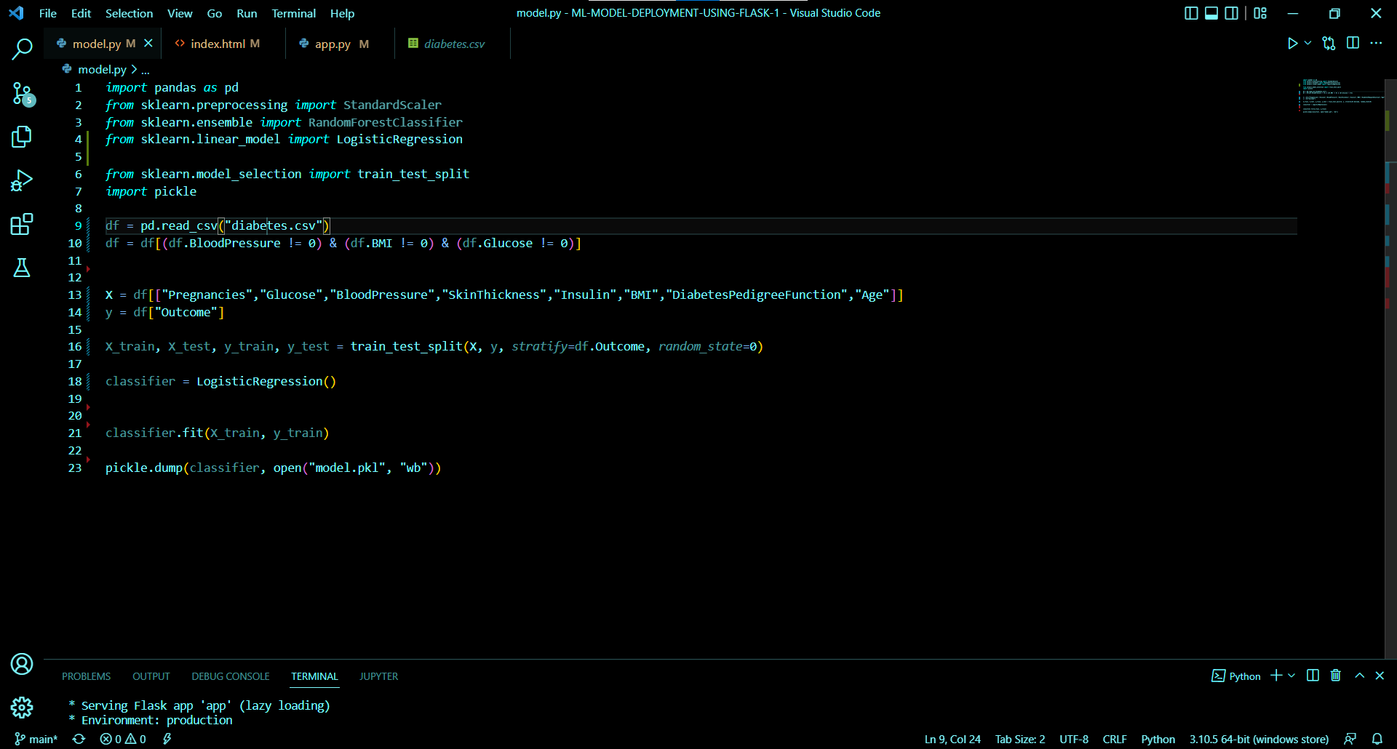

Step 2: I created the Flask application where the computer will render a basic HTML page to display the contents of the machine learning process.

Step 3: I created a basic HTML structure to ask the user for input and display the predicted answer that the computer will guess based on logistic regression.

